Tasks

1. Create a table comparing three offline marketing channels (such as print ads, retail displays, and events) and three online channels (such as Instagram ads, email marketing, and influencer posts) on the basis of reach, cost, and trust-building in India.

2. Write a short reflection (100-150 words) describing a recent time you trusted a brand more because of an offline experience (for example, seeing a Zomato food stall at a college fest, a Flipkart pop-up in a mall, or a Paytm QR code at a local shop).

3. List 5 offline marketing touchpoints you personally encountered in the last week (such as posters, product demos, branded merchandise, billboards, or event sponsorships) and briefly describe where and how you noticed each one.<br><br><em><strong>Hint:</strong> Think about your commute, college campus, shopping trips, or social events.</em>

4. Read the case study on how Amul or Fevicol built their brand without the internet, then identify and explain two specific offline tactics they used that would still be effective for a new brand today. give me the answer with example

Answers

1. Comparison of Offline and Online Marketing Channels in India
Marketing Channel | Type | Reach in India | Cost | Trust-Building | Example
Print Ads | Offline | Medium – reaches local/regional audiences | Medium–High | High | Newspaper ad for a local clothing store
Retail Displays | Offline | Medium – reaches customers at the point of purchase | Medium | High | Branded display of a new Pepsi product in a supermarket
Events | Offline | Medium–High – depends on event size | Medium–High | Very High | A brand sponsoring a college fest
Instagram Ads | Online | Very High – can target specific age, city and interests | Low–Medium | Medium | A music brand promoting a new song to Indian users
Email Marketing | Online | Medium – depends on subscriber list | Low | Medium–High | Flipkart sending a sale email to customers
Influencer Posts | Online | High – depends on influencer followers | Medium–High | High | A fitness influencer promoting a sports shoe
Example: A new café could use Instagram ads to reach many young people, while a college event sponsorship could help students physically experience the brand and build stronger trust.

2. Short Reflection – Offline Experience
Reflection on an Offline Brand Experience
Recently, I trusted a brand more after seeing its presence at a local shop. I noticed a Paytm QR code displayed clearly near the payment counter. I had already heard about Paytm online, but seeing the QR code being used by a real shopkeeper made the brand feel more reliable and useful. I could see that customers were actually using it for daily payments. This offline experience gave me more confidence because the service was not just something I saw on social media or advertisements. It was being used in a real-life situation. I realized that offline marketing can create trust because customers can directly see how a product or service works. It also makes a brand feel more familiar and connected to everyday life.

3. Five Offline Marketing Touchpoints
No. | Marketing Touchpoint | Where I Noticed It | How I Noticed It
1 | Posters | College campus | I saw a poster promoting a college event near the entrance.
2 | Billboards | On the road during commute | I noticed a large advertisement for a clothing brand on a roadside billboard.
3 | Retail Display | Local supermarket | A product had a special branded display placed near the checkout counter.
4 | Branded Merchandise | College/event | I saw students and organizers using branded T-shirts and badges during an event.
5 | QR Code | Local shop | I noticed a Paytm/UPI QR code at the payment counter and saw customers using it.
Example: These touchpoints are effective because people encounter them naturally while travelling, studying, shopping, or attending events.

4. Case Study – Amul's Offline Marketing

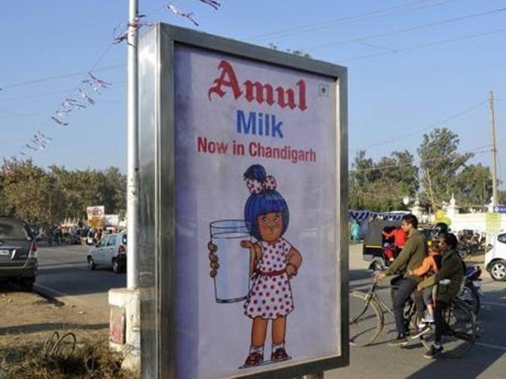
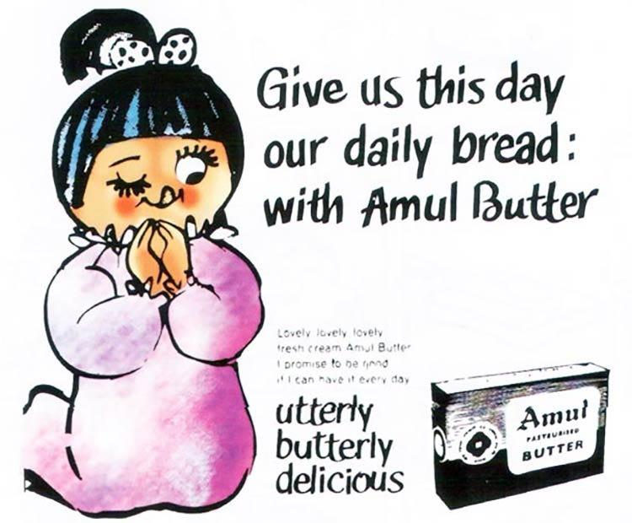
6

Case Study: Amul
Amul became one of India's most recognizable brands through strong offline advertising and distribution, even before digital marketing became popular.

Tactic 1: Memorable Outdoor Advertising
Amul used its famous Amul Girl and topical advertisements on billboards, hoardings and other physical advertising spaces.
Why it worked:
- Simple and memorable messages
- Connected advertisements with current events and Indian culture
- High visibility in public places
- Created strong brand recognition
Example for a new brand:
A new local café could put creative posters around colleges with a memorable line such as:
"Assignment ka stress? Coffee ka best!"
This could make students remember the café.

Tactic 2: Strong Physical Distribution and Retail Presence
Amul products were made easily available through milk booths, retailers, supermarkets and local shops. Customers could repeatedly see and buy the products in their everyday environment.
Why it worked:
- Easy product availability
- Customers could physically see the product
- Repeated exposure increased familiarity
- Retailers became an important connection between the brand and customers
Example for a new brand:
A new packaged-snack company could place its products in college canteens, local grocery stores and small supermarkets. Students would see the product repeatedly and could try it immediately.

